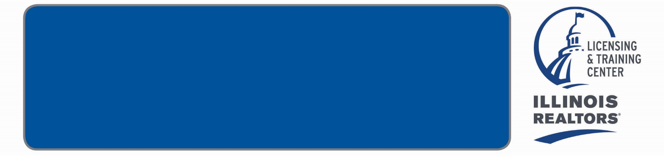

**Quincy Association of REALTORS®**

*(check all courses you would like to purchase)*

**HOME STUDY COURSES**

|  |  |
| --- | --- |
| Complete your  C.E. requirements  at home with these programs!    QAR Member  **One Course (3 Hours)**  **$40**  **Non-Member**  **One Course (3 Hours)**  **$45** | **COR 1654 - Core A: Fair Housing, Agency, License Law & Escrow** #564001718  **COR 1655 – Core B: Legal Issues – Disclosure & Anti-trust** #564001820  **ETH 1515 -** **Ethics in Real Estate** #564002399, 3 elective  **PM 613 - Leasing Residential Property**  #564001798, 3 elective   **RD 920 - Harassment in the Workplace** #564002281, 3 elective  Name ______________________________________________________  NRDS or License #: ___________________________________________  Business Address: ____________________________________________  City/State: ______________________________ Zip: ________________  Phone:( )___________________ Fax:( )____________________  Email: ______________________________________________________  Payment: *Check enclosed |

**Call or email the QAR Board Office to schedule a date and time to come take a Home Study Course. Phone: 217-228-0652 Email: mls@adams.net**